**JOB SEARCH MANAGER**

1. **ABSTRACT:**

Job Search Manager is a web application aimed at providing the facility to the user for tracking his Job Applications. This software will help the user by keeping track of the Websites where the user applies for jobs including his Login credentials.

This project is based on MERN Stack, a high-level JavaScript-based framework that enables the rapid development of secure and maintainable websites.

1. **INTRODUCTION:**

Keeping track of Job Applications is tedious as there are lots of job opportunities available. With those available opportunities, the people used to apply for the job with different Job Portals. By doing so as the time passes they forget about the applications to which they have applied previously or they will forget about the Login credentials which are set at the time of submitting the Job Application. This is a major problem which is faced by every person. This affects the career of the person as the user would lose any valuable chance of getting employed in any of the applied companies by not checking the status of the application frequently.

To get rid of all those negative aspects of Job Applications, a Job Search Manager is developed which will keep track of the user’s Job Applications with the information like Date of Applying, Job Role which the user applied, and Login credentials at the time of submission of application. It is also able to display the applications in a Last In First Out order by sorting them with the date of submission. The project can segregate the applications by the status of the applications like Applied, No Longer Under Consideration, Rejected, Wishlist, etc. By doing so we can easily track our application and get a suitable job for the user.

1. **SOFTWARE USED:**

For the development of the Job Search Manager, MERN Stack Framework has been implemented. MERN is a high-level JavaScript-Based Web Framework that encourages rapid development and clean, pragmatic design.

The abbreviation for MERN is as follows:

1. **M** **– MongoDB :**

MongoDB is an open-source NoSQL database management program. NoSQL databases are quite useful for working with large sets of distributed data. MongoDB is a tool that can manage document-oriented information, and store or retrieve information.

1. **E – ExpressJS :**

Express is a minimal and flexible Node.**js** web application framework that provides a robust set of features for web and mobile applications.

1. **R – ReactJS :**

React is a free and open-source front-end JavaScript library for building user interfaces based on UI components.

1. **N – NodeJS :**

Node.js is an open-source, cross-platform, back-end JavaScript runtime environment that runs on the V8 engine and executes JavaScript code outside a web browser.

The Project is embedded with **JWT (JSON Web Token)** which is used for authenticating the user.

**Tailwind CSS** which is an efficient framework for designing the front end is also used for creating this project which makes the project more attractive.

## DEVELOPMENT MODELS

### There are some Software Process Models listed below –

* Waterfall Model
* Prototype Model

## Waterfall Model

The waterfall model is probably the oldest and the best-known as far as software development process models are concerned. The role of the waterfall model in software engineering is as important as its role in software testing. Of course, over the years, there are several other software process models which have been designed and implemented, but what is true is that a lot of them are based (in some way or the other) on the fundamental principle of the waterfall model. On that note, let us examine the waterfall model in detail.

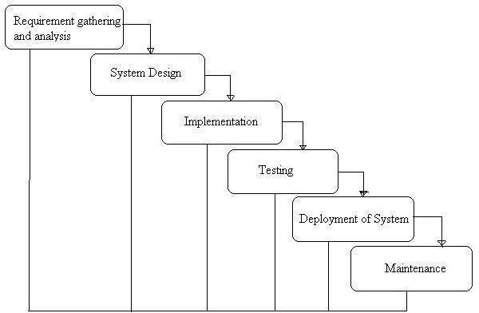

(**Waterfall Model**)

### Advantages of waterfall model:

* Simple and easy to understand and use.
* Easy to manage due to the rigidity of the model – each phase has specific deliverables and a review process.
* Phases are processed and completed one at a time.
* Works well for smaller projects where requirements are very well understood.

### Disadvantages of waterfall model:

* Once an application is in the testing stage, it is very difficult to go back and change something that was not well-thought-out in the concept stage.
* No working software is produced until late during the life cycle.
* High amounts of risk and uncertainty.
* Not a good model for complex and object-oriented projects.
* Poor model for long and ongoing projects.
* Not suitable for the projects where requirements are at a moderate to high risk of changing.
* The project is short.

## Prototype Model

The basic idea here is that instead of freezing the requirements before a design or coding can proceed, a throwaway prototype is built to understand the requirements. This prototype is developed based on the currently known requirements. By using this prototype, the client can get an “actual feel” of the system, since the interactions with the prototype can enable the client to better understand the requirements of the desired system. Prototyping is an attractive idea for complicated and large systems for which there is no manual process or existing system to help determine the requirements. The prototypes are usually not complete systems and many of the details are not built in the prototype. The goal is to provide a system with overall functionality.

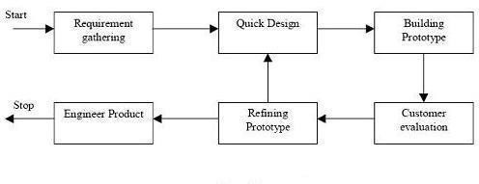

(**Prototype Model**)

### Disadvantages of Prototype model:

* This leads to implementing and then repairing ways of building systems.
* Practically, this methodology may increase the complexity of the system as the scope of the system may expand beyond the original plans.
* An incomplete application may cause the application not to be used as the full system was designed Incomplete or inadequate problem analysis.

## When to use the Prototype model:

A prototype model should be used when the desired system needs to have a lot of interaction with the end-users.

Typically, online systems and web interfaces have a very high amount of interaction with end-users and are best suited for the Prototype model. It might take a while for a system to be built that allows ease of use and needs minimal training for the end-user.

Prototyping ensures that the end-users constantly work with the system and provide feedback which is incorporated into the prototype to result in a useable system. They are excellent for designing good human-computer interface systems.

**DIAGRAMS**

1. **USE CASE DIAGRAM:**

